**电子科技大学信息与软件工程学院**

**School of Information and Software Engineering**

**University of Electronic Science and Technology of China**

**实 验 报 告**

**Lab Report**

**Student ID 2017221501036**

**Student Name KASSAW ABRAHAM MULAT**

**（Lab） Course Name MULTIMEDIA APPLICATION BASICS**

**Course Teacher XU XIANG**



**XU XIANG QQ**：**5322961**

**Email**： [**xuxiang@uestc.edu.cn**](mailto:xuxiang@uestc.edu.cn)



Multimedia-experiment-1

**n1**

1. Use MATLAB function ‘imread( )’ to load the image ‘flower.tif’，and save to a variable ‘x’;

>>x = imread('flower.tif');

1. Use MATLAB function ‘whos’ to read the information of the

image ‘flower’:

>> whos x

Name Size Bytes Class Attributes

x 1200x1600x3 5760000 uint8

1. Use MATLAB function ‘imshow()’ to plot the image/variable;

>> imshow(x);

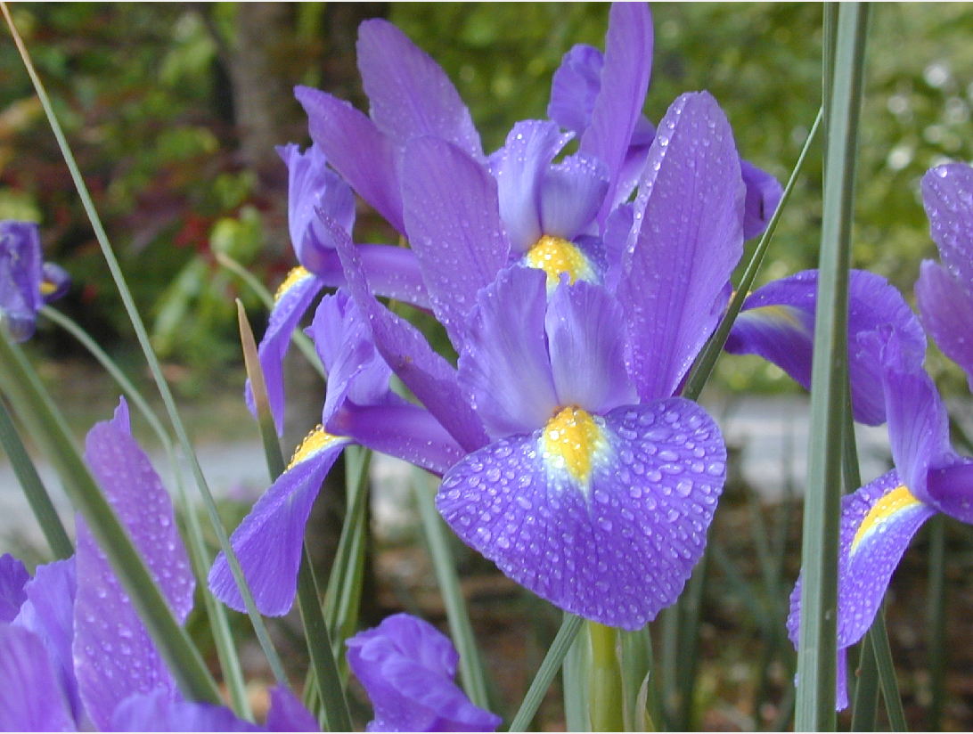

4． Use MATLAB function ‘imfinfo’ to get the information of

this image；

>> info = imfinfo('C:\Users\Abrish\Desktop\3.1\Multi media\Experiment\Exp1\flower.jpg');

>> info

info =

struct with fields:

Filename: 'C:\Users\Abrish\Desktop\3.1\Multi media\Experiment\Exp1\flower.jpg'

FileModDate: '01-Nov-2019 15:27:45'

FileSize: 202339

Format: 'jpg'

FormatVersion: ''

Width: 1600

Height: 1200

BitDepth: 24

ColorType: 'truecolor'

FormatSignature: ''

NumberOfSamples: 3

CodingMethod: 'Huffman'

CodingProcess: 'Sequential'

Comment: {}

5. Use MATLAB function ‘imwrite()’ to save this image/variable with a different name, for instance, ‘flower.jpg’;

>> imwrite(x,'flower.jpg','JPG');

>> Image = imread(‘flower.jpg’);

>>Imshow(image);

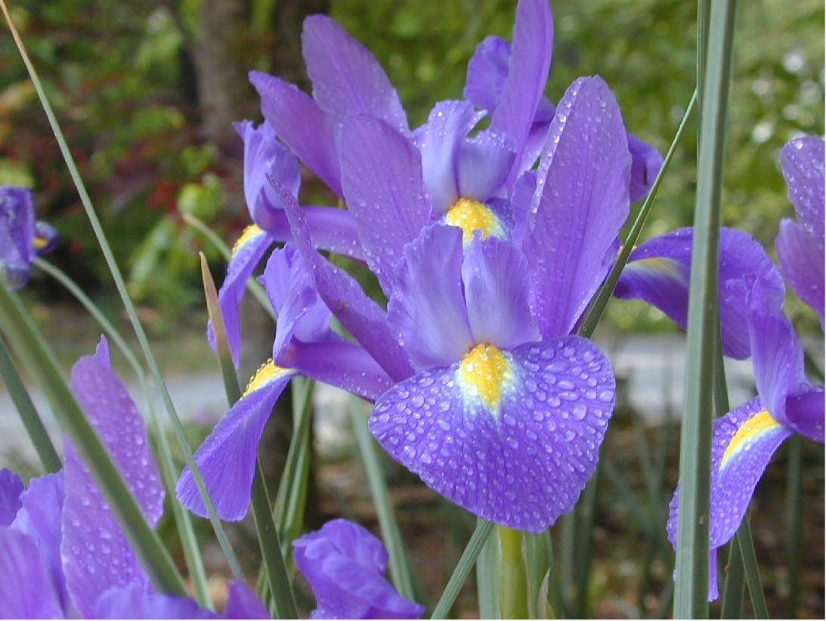

figure flower.jpg



**Experiment 1**

6． Use MATLAB function ‘imwrite()’ to save this tif format to ‘bmp’，for example ‘flower.bmp’， Use MATLAB function

‘subplot’ to plot these three images together and compare

the quality. In addition, compare the storage size between tif,jpg and bmp formats.

%changing image format and plotting together

x = imread('flower.tif');

imwrite(x,'flower.bmp','BMP');

A = imread('Flower.tif');

B = imread('flower.jpg');

C = imread('flower.bmp');

subplot(3,3,1); subimage(A); title('flower.tif');

subplot(3,3,2); subimage(B); title('flower.jpg');

subplot(3,3,3); subimage(C); title('flower.bmp');

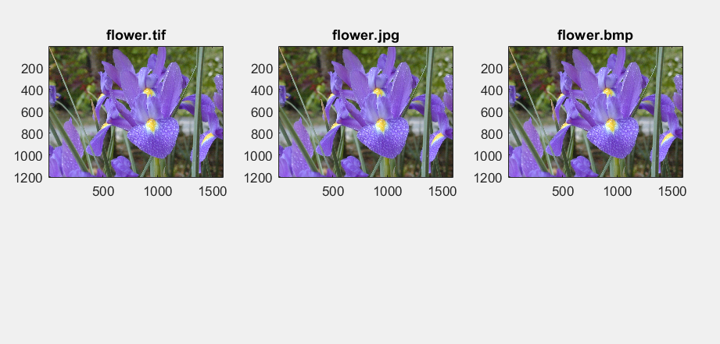

Storage size comparison

|  |  |
| --- | --- |
| Image format | Size |
| flower.tif | 3.20 MB (3,366,306 bytes) |
| flower.jpg | 197 KB (202,339 bytes) |
| Flower.bmp | 5.49 MB (5,760,054 bytes) larger  ,higher quality |

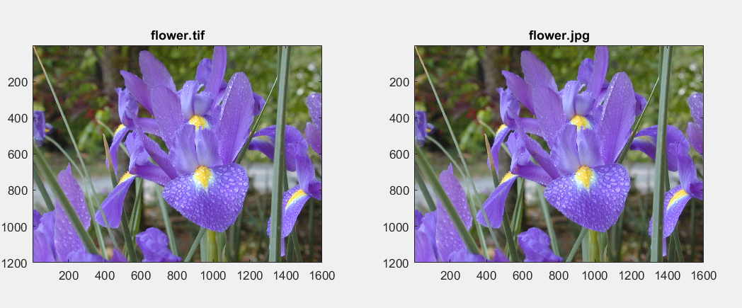

The larger the size of the image the better the quality they have.

here flower.bmp has a higher storage size and better quality than the flower.tif and flower.jpg. (even though larger file size is undesirable).

1. Use MATLAB function ‘im2bw’ to turn ‘Lenna.jpg’ and ‘camema.jpg’ to be binary images, and plot them out.

>> m = imread('Lenna.jpg')

>> imshow(m);

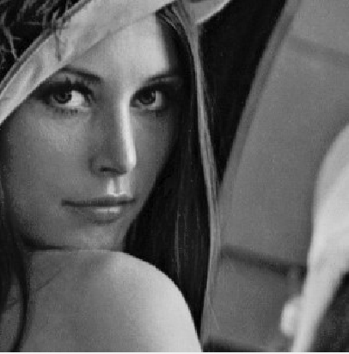

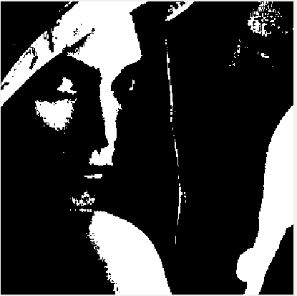

>> bw = im2bw(m);

>> imshow(bw);

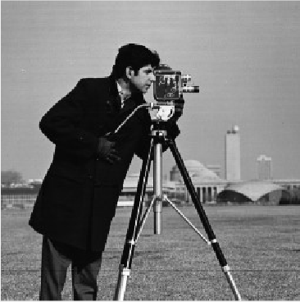

>> n = imread('cameman.jpg');

>> imshow(n);

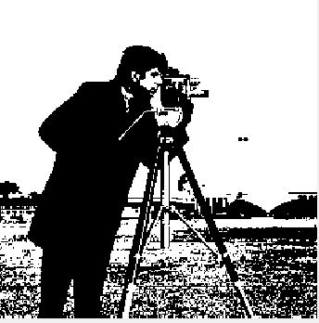

>> bw1 = im2bw(n);

>> imshow(bw1);

1. For image ‘flower.tif’，turn it from RGB color space to YCbCr，plot the Y element。

%changing flower.tiff to YCBCR and plotting the Y element

RGB = imread('flower.tif');

YCBCR = rgb2ycbcr(RGB);

Y = YCBCR(:,:,1);

imshow(Y);

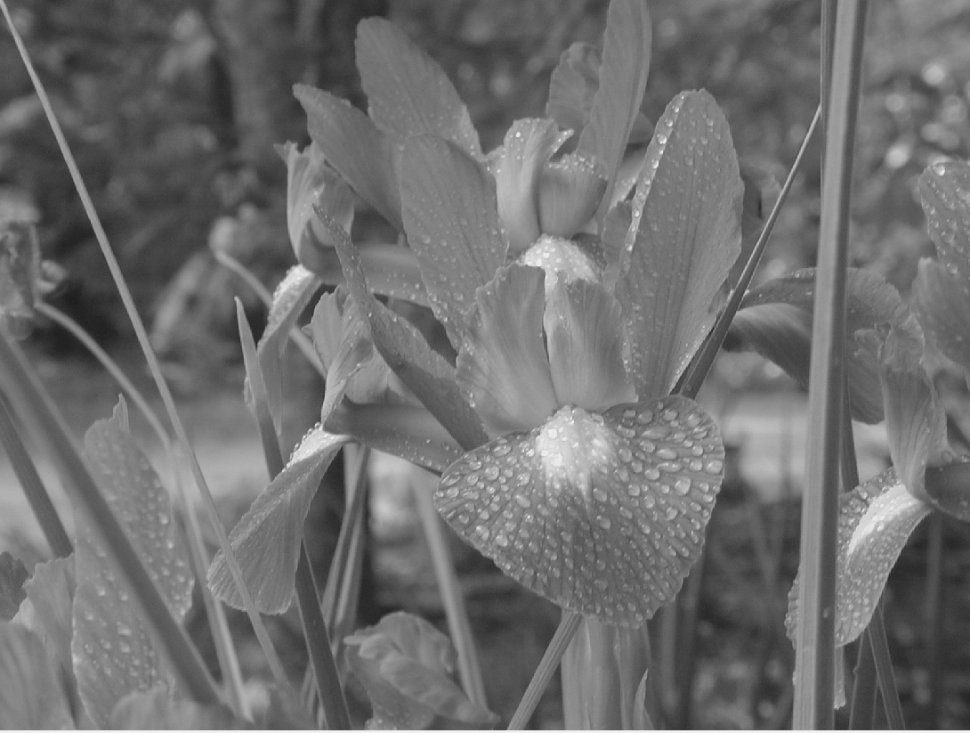

figure ycbcr y element

s



**Experiment 1**

tt

1. To turn the pixel value of ‘flower.tif’ to be inverse，for

example：if the pixel value is a，then turn its value to be

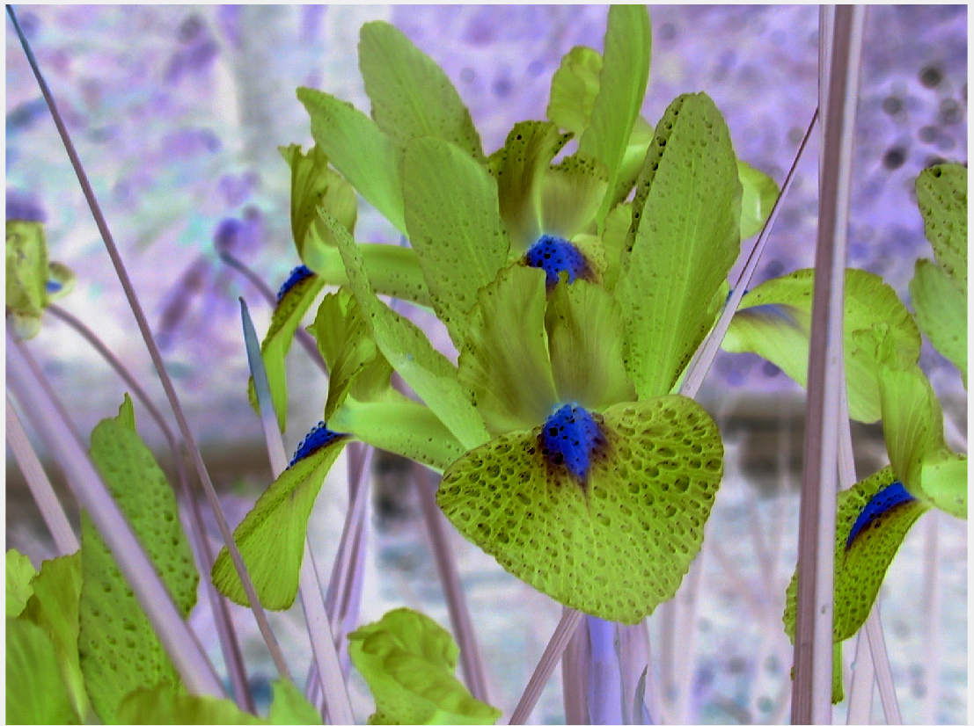255-a，and plot the

image

%inverse

a= imread('flower.tif');

ainverse = 255-a;

imshow(ainverse);

1. Use subplot to plot the RED, GREEN, BLUE elements of the color image ‘flower.tif’;

%separting the Red, Green and Blue channels of colored image

RGB = imread('flower.tif');

red = RGB(:,:,1);

green = RGB(:,:,2);

blue = RGB(:,:,3);

ab = zeros(size(RGB,1),size(RGB,2), class(RGB)); % all black

red_channel = cat(3,red,ab,ab);

green_channel = cat(3,ab,green,ab);

blue_channel = cat(3,ab,ab,blue);

subplot(3,3,2); subimage(RGB); title('Original RGB image');

subplot(3,3,4); subimage(red_channel); title('Red channel');

subplot(3,3,5); subimage(green_channel); title('Green channel');

subplot(3,3,6); subimage(blue_channel); title('Blue channel');

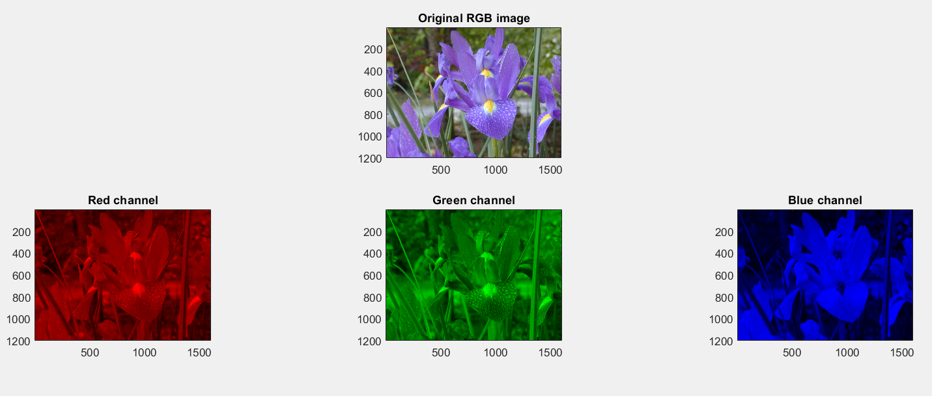

1. For images ‘lenna.jpg’ and ‘camema.jpg’ ，sample them

with the sampling rate 2, 4, 8, and 16, plot the results and

compare them.

% image sampling Lenna.jpg

image1 = imread('Lenna.jpg');

sample_2 = image1(1:2:end, 1:2:end);

sample_4 = image1(1:4:end, 1:4:end);

sample_8 = image1(1:8:end, 1:8:end);

sample_16 = image1(1:16:end, 1:16:end);

subplot(3,2,1); imshow(image1); title('Original image');

subplot(3,2,2); imshow(sample_2); title('Sampled by 2');

subplot(3,2,3); imshow(sample_4); title('Sampled by 4');

subplot(3,2,4); imshow(sample_8); title('Sampled by 8');

subplot(3,2,5); imshow(sample_16); title('Sampled by 16');

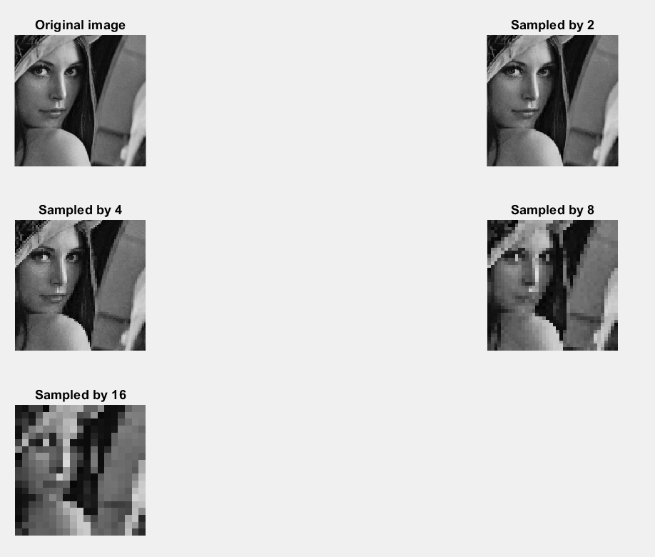

%sampling cameman.jpg

image2 = imread('cameman.jpg');

sp_2 = image2(1:2:end, 1:2:end);

sp_4 = image2(1:4:end, 1:4:end);

sp_8 = image2(1:8:end, 1:8:end);

sp_16 = image2(1:16:end, 1:16:end);

subplot(3,2,1); imshow(image2); title('Original image');

subplot(3,2,2); imshow(sp_2); title('Sampled by 2');

subplot(3,2,3); imshow(sp_4); title('Sampled by 4');

subplot(3,2,4); imshow(sp_8); title('Sampled by 8');

subplot(3,2,5); imshow(sp_16); title('Sampled by 16');

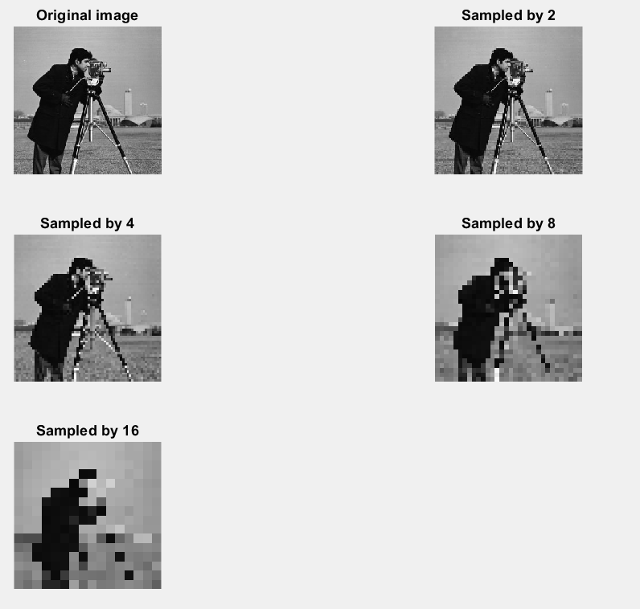

1. Perform Huffman coding for three images. (rgb2gray)

%huffman coding

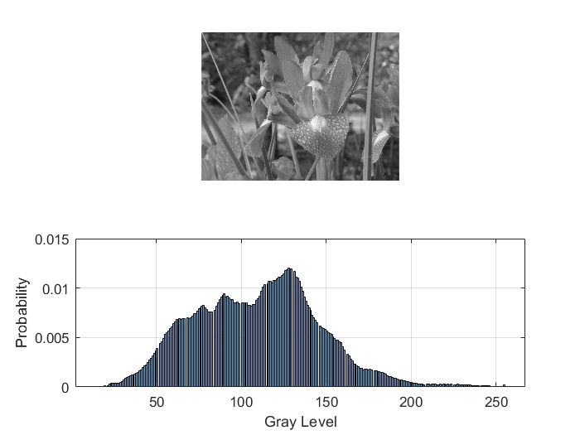 image1 = imread('flowergray.jpg');

image2 = imread('Lenna.jpg');

image3 = imread('cameman.jpg');

figure;

subplot(2, 1, 1);

imshow(image1);

subplot(2, 1, 2);

hisObj1 = histogram(image1, 256, 'Normalization', 'probability')

grid on;

xlabel('Gray Level');

ylabel('Probability');

figure;

subplot(2, 1, 1);

imshow(image2);

subplot(2, 1, 2);

hisObj2 = histogram(image2, 256, 'Normalization', 'probability')

grid on;

xlabel('Gray Level');

ylabel('Probability');

figure;

subplot(2, 1, 1);

imshow(image3);

subplot(2, 1, 2);

hisObj3 = histogram(image3, 256, 'Normalization', 'probability')

grid on;

xlabel('Gray Level');

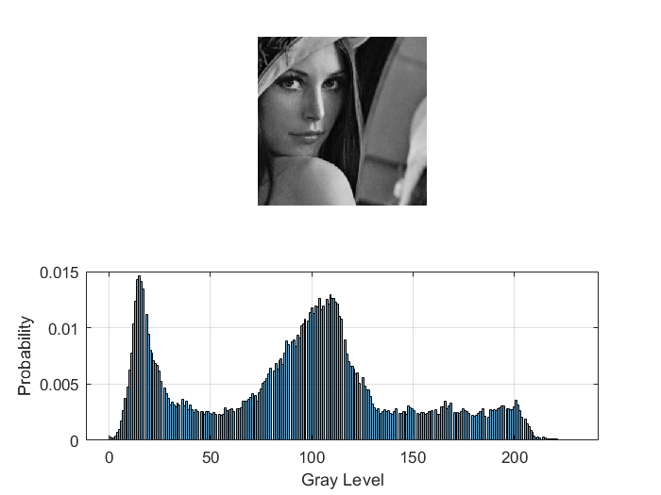 ylabel('Probability');

%--------------- find the probability of each image

p = hisObj1.Values;

q = hisObj2.Values;

r = hisObj3.Values;

%----------function to create huffman dictionary

[hp,ep]=Huffman_code(p);

[hq,eq]=Huffman_code(q);

[hr,er]=Huffman_code(r);

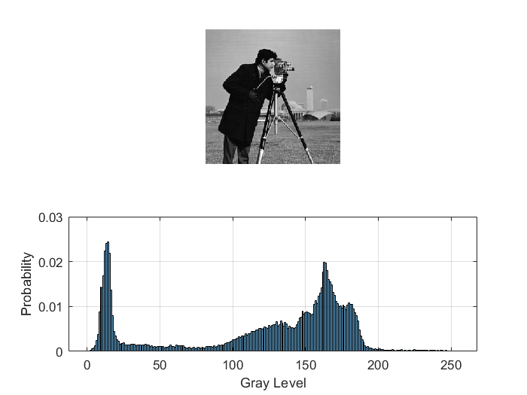

**Experiment Experience**

The experiment helped me to gain the technique to convert an image into digital format and perform operations like reading, writing, changing to different formats and so on, on the image to get an enhanced image or extract some useful information from it using matlab.